Cross compile QT5 sources
using cross ng toolchain compiler that we created

http://doc.qt.io/qt-5/configure-options.html

First we need to make sure our croos tool ng compiler is in the path:
lets create an ACTIVATE.sh script and source it

export PATH=/home/first/x-tools/arm-unknown-linux-gnueabihf/bin:$PATH

source ACTIVATE.sh

make sure you can call it any where:

rm-unknown-linux-gnueabihf-gcc

arm-unknown-linux-gnueabihf-gcc: fatal error: no input files
compilation terminated.

A list of platform can be found in: qtbase/mkspecs

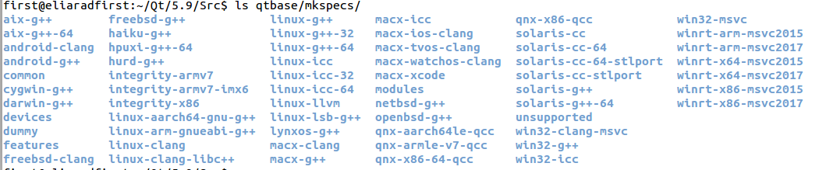

Note that we dont have our compiler that we create using cross too ng

lets create a mkspecs there for our compiler:

Src/qtbase/mkspecs$ cp -r linux-arm-gnueabi-g++ arm-unknown-linux-gnueabihf

This is the current qmake.conf that we copied from:

#
# qmake configuration for building with arm-linux-gnueabi-g++
#

MAKEFILE_GENERATOR = UNIX
CONFIG += incremental
QMAKE_INCREMENTAL_STYLE = sublib

include(../common/linux.conf)
include(../common/gcc-base-unix.conf)
include(../common/g++-unix.conf)

# modifications to g++.conf
QMAKE_CC = arm-linux-gnueabi-gcc
QMAKE_CXX = arm-linux-gnueabi-g++
QMAKE_LINK = arm-linux-gnueabi-g++
QMAKE_LINK_SHLIB = arm-linux-gnueabi-g++

# modifications to linux.conf
QMAKE_AR = arm-linux-gnueabi-ar cqs
QMAKE_OBJCOPY = arm-linux-gnueabi-objcopy
QMAKE_NM = arm-linux-gnueabi-nm -P
QMAKE_STRIP = arm-linux-gnueabi-strip
load(qt_config)

We need to change the compiler prefix to arm-unknown-linux-gnueabihf

#
# qmake configuration for building with arm-unknown-linux-gnueabihf-g++
#

MAKEFILE_GENERATOR = UNIX
CONFIG += incremental
QMAKE_INCREMENTAL_STYLE = sublib

include(../common/linux.conf)
include(../common/gcc-base-unix.conf)
include(../common/g++-unix.conf)

# modifications to g++.conf
QMAKE_CC = arm-unknown-linux-gnueabihf-gcc
QMAKE_CXX = arm-unknown-linux-gnueabihf-g++
QMAKE_LINK = arm-unknown-linux-gnueabihf-g++
QMAKE_LINK_SHLIB = arm-unknown-linux-gnueabihf-g++

# modifications to linux.conf
QMAKE_AR = arm-unknown-linux-gnueabihf-ar cqs
QMAKE_OBJCOPY = arm-unknown-linux-gnueabihf-objcopy
QMAKE_NM = arm-unknown-linux-gnueabihf-nm -P
QMAKE_STRIP = arm-unknown-linux-gnueabihf-strip
load(qt_config)

This new directory will be our -xplatform compile flag

./configure -platform
./donddddfigure -platform

./configure -platform
./configure -platform
./configure -platform
./configure -xplatform arm-unknown-linux-gnueabihf-g++

-device - a specific device or chipsets. The list of devices that configure is compatible with are found in qtbase/mkspecs/devices. For more information, visit the Devices Wiki page.

We can create a new device and put all the options there

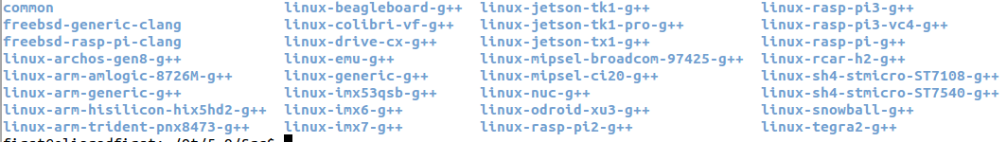
lets use raspberry pi 3

./configure -xplatform arm-unknown-linux-gnueabihf-g++ -device linux-rasp-pi3-g++

-device-option - sets additional qmake variables. For example, -device-option CROSS_COMPILE=<path-to-toolchain> provides the environment variable, CROSS_COMPILE, as needed by certain devices.
/configure -xplatform arm-unknown-linux-gnueabihf-g++ -device linux-rasp-pi3-g++
-device-option CROSS_COMPILE=/home/first/x-tools/arm-unknown-linux-gnueabihf/bin

